**WORKSHOP RUBY**

**1 LOPEZ ALMEIDA, ANDRES ISAIAS**

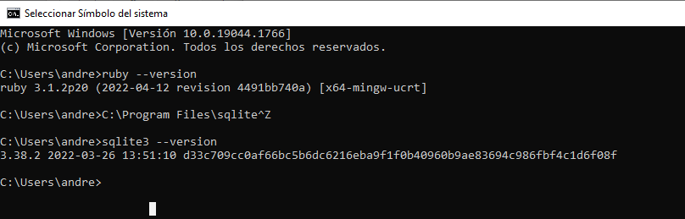

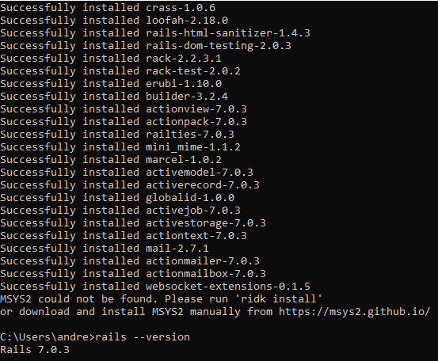

**2 MALTE VILLARREAL, DENNIS MARCELO**

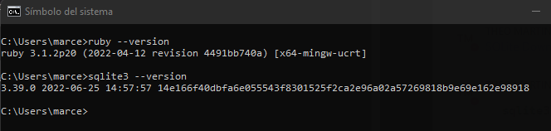



**3 MEDINA ARMIJOS, MARTIN ANDRES**

**4 PAEZ ZAPATA, DIEGO ALEXANDER**

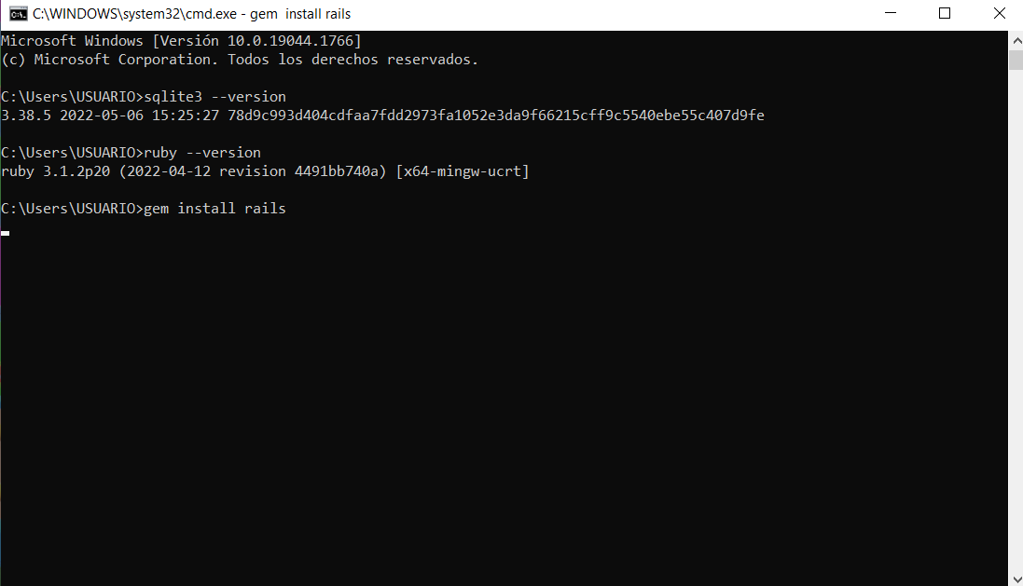

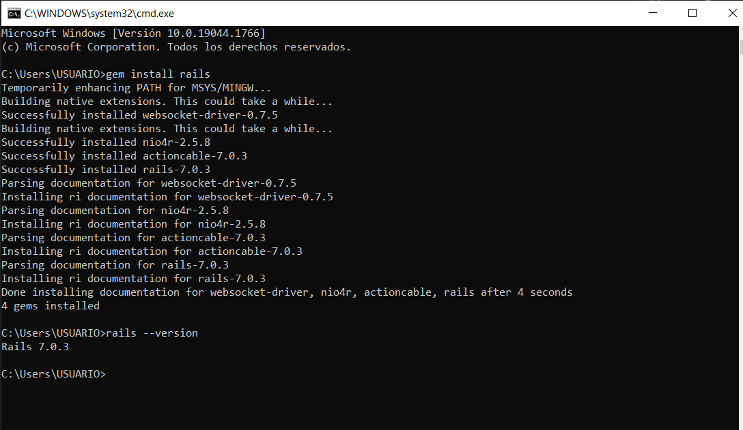

**5 PAREDES MEDRANO FERNANDO PATRICIO**

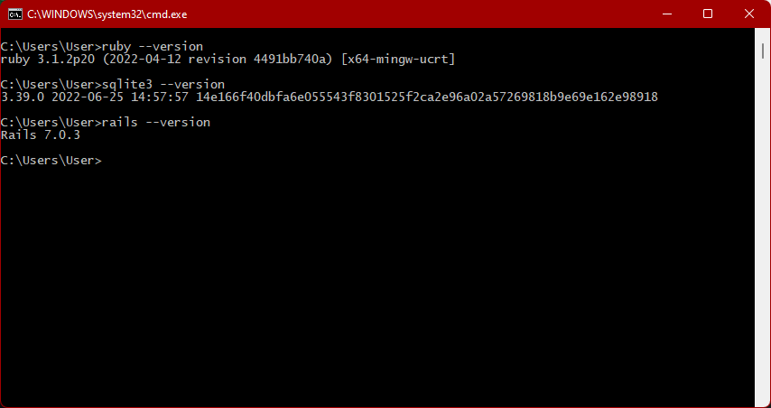

**6 POMA AGUILAR, DAYSE NICOLE**

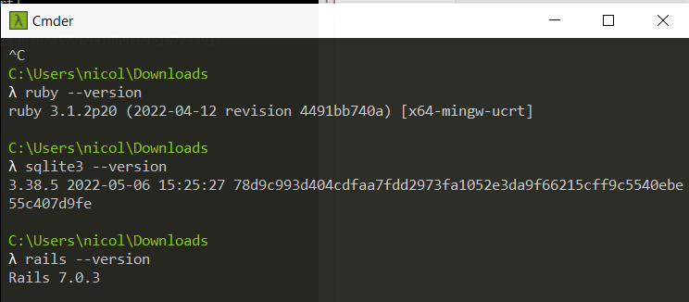

**7 RIASCOS MORENO, ERICK GERMAN**

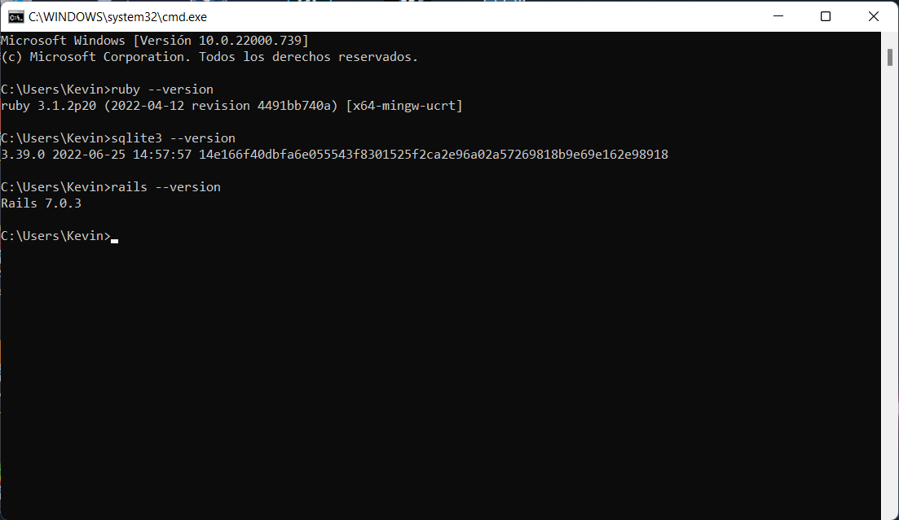

**8 RISUEÑO ZAPATA, SANTIAGO FABIAN**

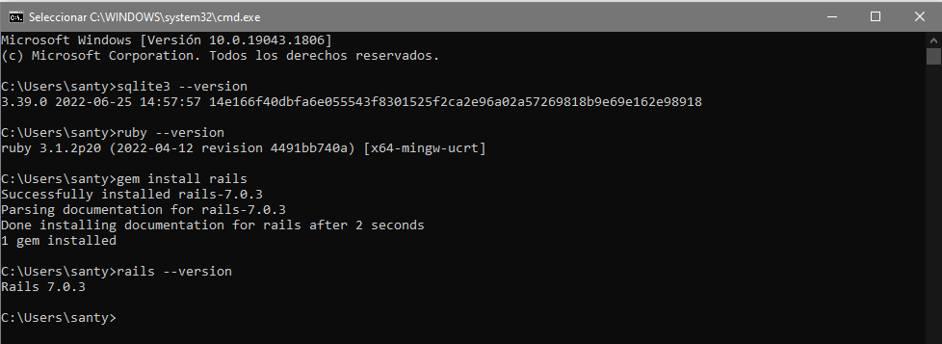

**9 RIVERA VEGA, STALIN BLADIMIR**

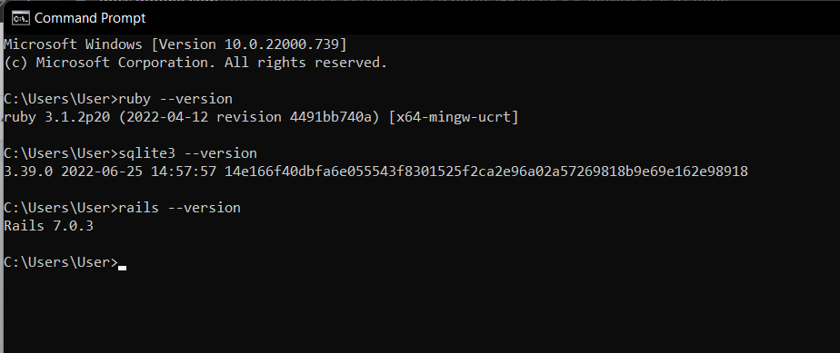

**10 ROMAN VERDEZOTO, IVETTE YULLIANA**

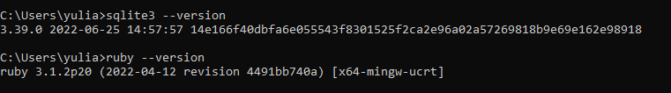

**11 ROSERO MOSQUERA, THEO MARTIN**

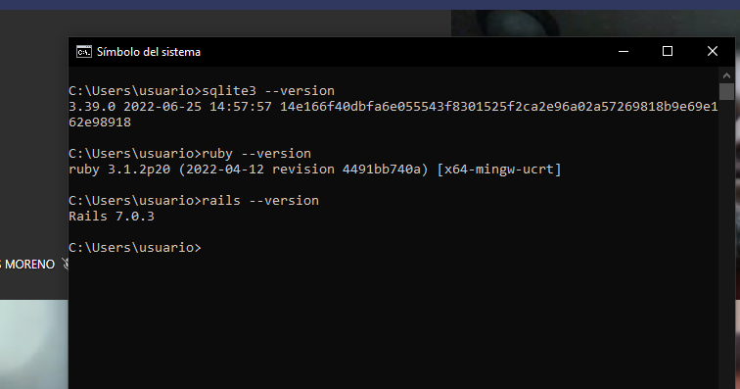

**12 RUIZ MAFLA, JERICÓ BENJAMIN**

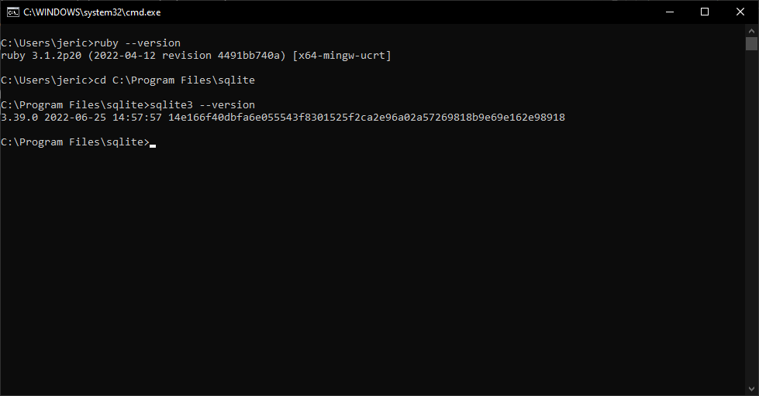

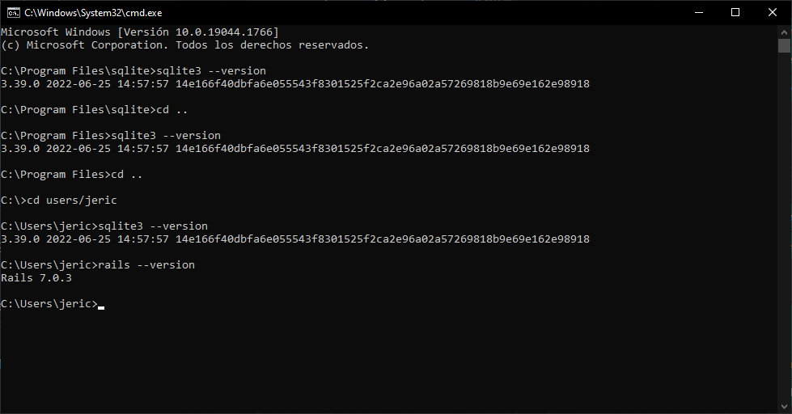

**13 SUNTAXI LEMA, STALYN FRANCISCO**

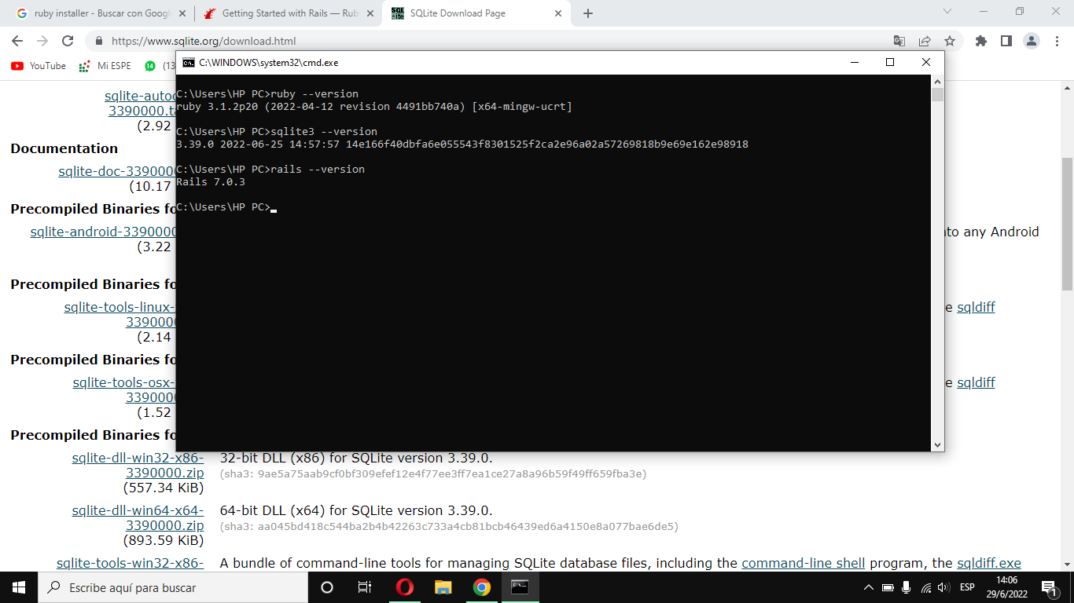

**14 TIAMBA ALUCHO, HENRY ANTHONY**

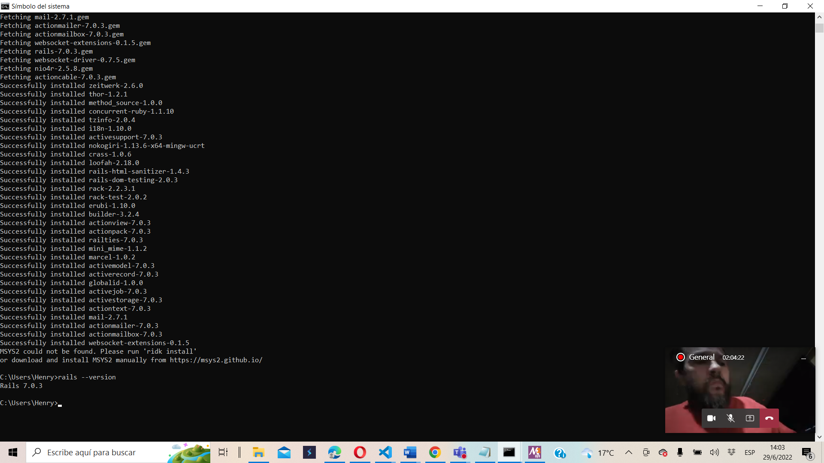

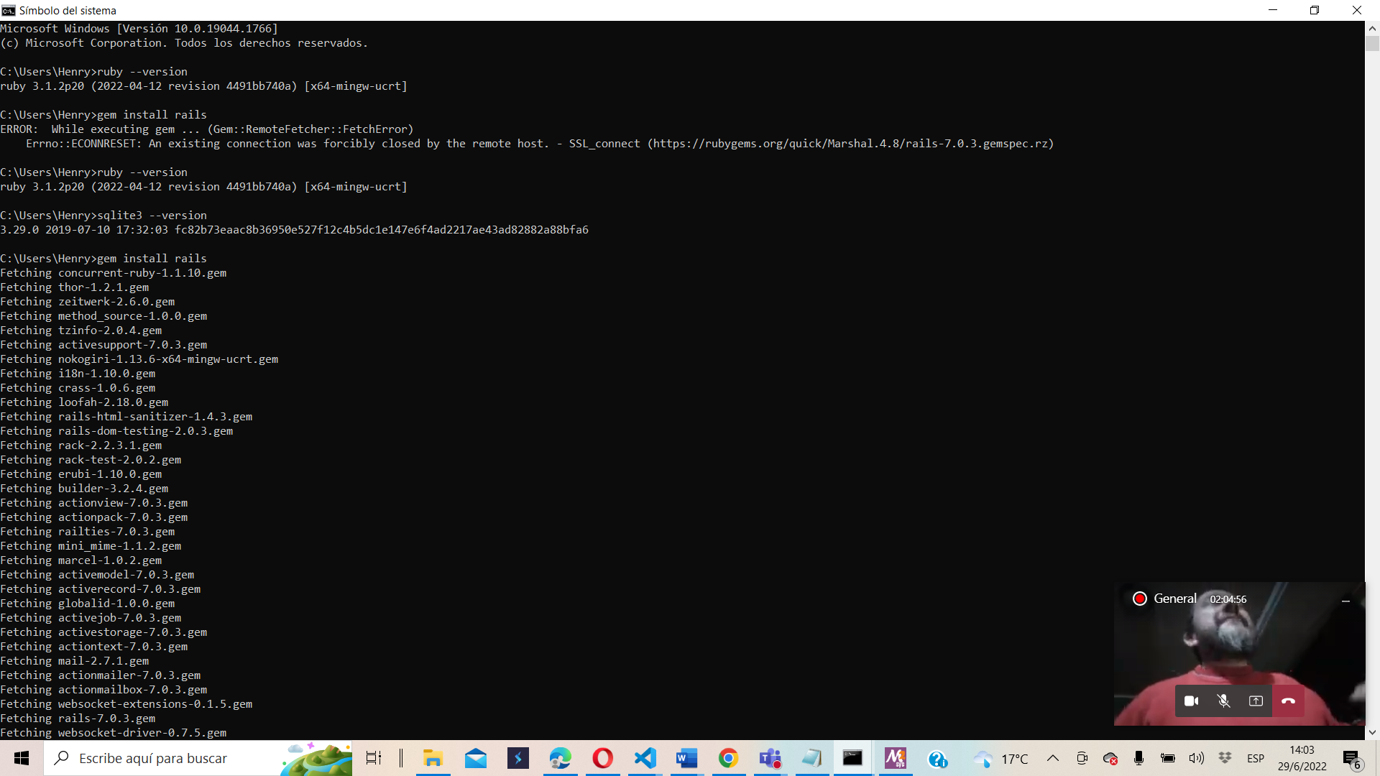

**15 VACA CHUNGANA, EDISON MAURICIO**

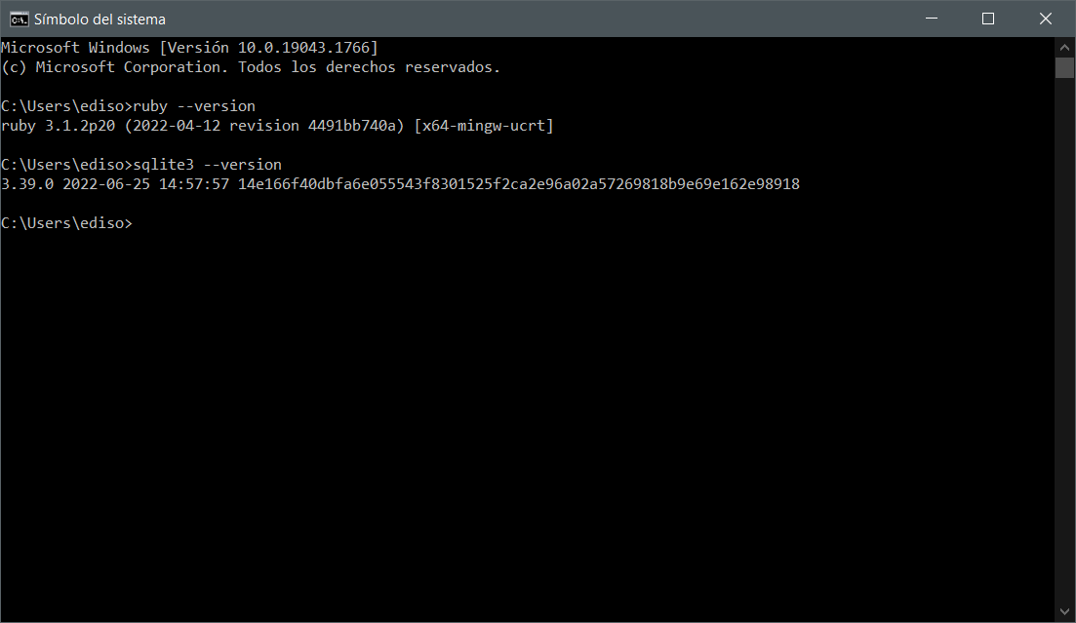

**16 VALAREZO CORREA, ANDRES GERARDO**

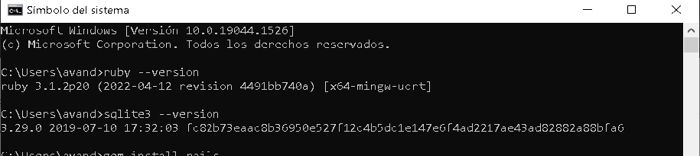

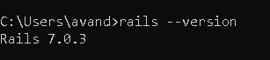

**17 YANZAPANTA ONTANEDA, BRYAN SEBASTIAN**

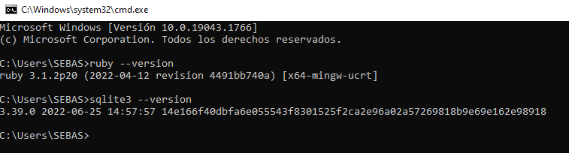

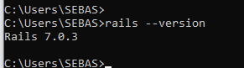

**18 YEPEZ CHANDI, CHRISTOPHER DANIEL**

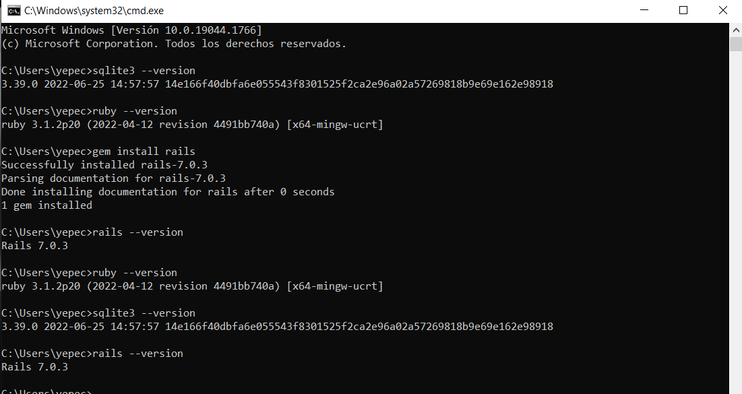

**19 ZAPATA SANDOVAL, JONATHAN ISMAEL**

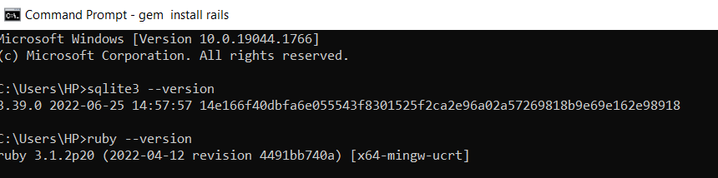

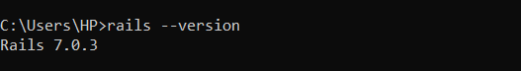

**20 ZAPATA ZAPATA, SEBASTIAN ALEXANDER**



